1)

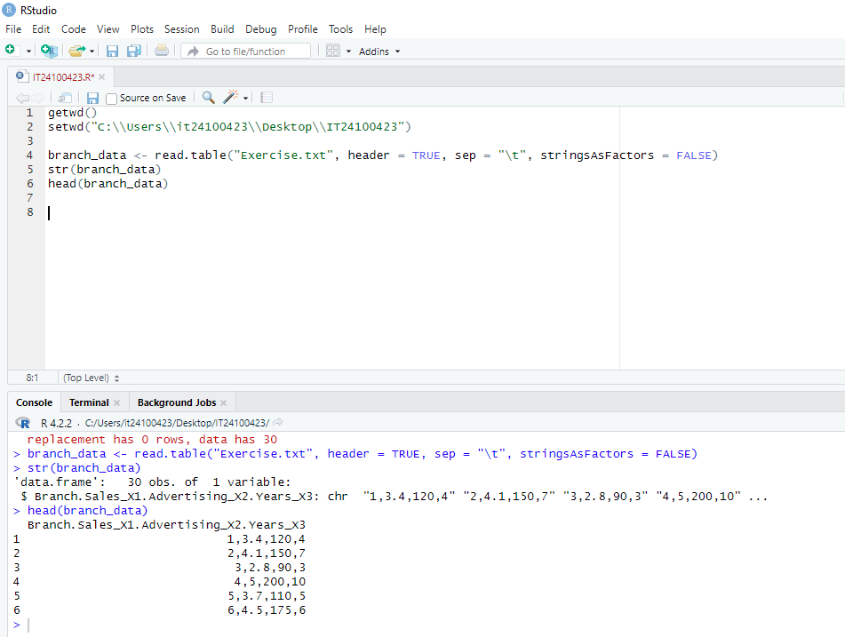

2)

3)



4)

5)

